**Git and GitHub**

**Git:** is a version control system is a tools that helps to track changes in code

**Why to use it**

1. Popular
2. Free and Open Source
3. Fast and scalable

**Git Helps**

1. Track the History
2. Collaborate

**GitHub:** Website that allows developers to store and manage their code using Git.

Folders are said as repository or repos

**Steps to Create a New Repo form Git**

**New repot -> public/private -> Choose readme file -> Click Create Repository**

**Commit:** When we final our changes, the developer will commit those changes.

**Setting up Git**

**Configuring Git**

*git config –global user.name “My_Name”*

*git config –global user.email* [*someone@gmail.com*](mailto:someone@gmail.com)

*git config –list*

**Clone and Status**

**Clone** – Cloning a repository on our local machine

**Locally:** *git clone url*

**Status**: Shows the status of the code

* *git status*

**Four Type of status**

1. **Untrack**: File not added into git new file
2. **Modified**: Changed file that has been added to git
3. **Staged**: File is ready to be committed
4. **Unmodified**: unchanged file

**Add and Commit**

**add –** it adds new or changed file in your working directory to the git staging area.

*git add <file name>*

**commit:** It is the record of change

*git commit -m “some message”*

**Push Command**

**push-** Upload local repo content to remote repo

*git push origin main*

**Init Command**

Make a simple folder a git repository in local system

*git init*

*git remote -v*

*git branch*

*git branch -M main (rename the name of master branch to main)*

*git push origin main*

**How to push this repo in GitHub?**

Make New Repo -> without readme.md -> (local) *git remote add origin <link> -> git branch -M main*

*git push -u origin main*

**Git Branches**

Branches are created to distribute the work effectively

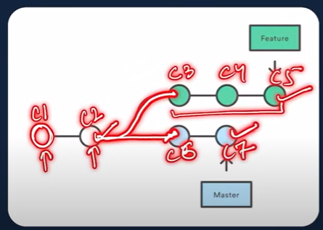

Branching and Merging

*git branch*

*git checkout -b feature1 _> to go and created new feature 1 branch*

*git branch -d feature2*

Merge

Local

git diff <branch_name>

git merge <branch_name>

using github

Pull Command brings remote changes to local

*git pull origin main*

**Merge Conflicts:** An event that takes place when git is unable to automatically resolve differences in code between two commits

**Undoing Changes**

1. **Staged Changes:** git reset file_name
2. **Commit Changes:** git reset Head~1
3. **Multiple Commit Changes:** git reset <commit hash>, git reset –hard <commit hash> it remove the changes in file to that point.

**Fork:** Rough copy of a repository